Patient __________________________ Gender ________ Age ________ Nurse _____________________
Ad. Dx ___________________________________________________ Code Status _________________________
Allergies ________________________________________________________________________________________
Fall Risk: Morse Score _________ No / Low / High Risk | Socks / Blanket / Bed Alarm / Walker / Cane / Brace / Hoyer
Isolation Precautions? Gloves Gown Mask Goggles Reason: ________________________________________

Past Medical History | Past Surgical History | IV Sites, Assessment, Meds
Report:

Activity | Independent | Dependent | Assistance needed (describe)
Feeding
Hygiene
Mobility
Elimination

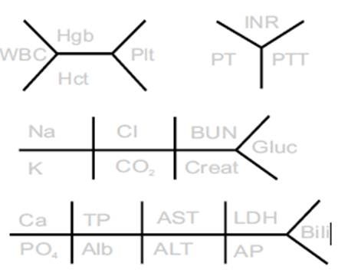
Diagnostics:

Time | Temp | HR | RR | BP | BG | Pain | SpO2

NEUROLOGICAL (headache, fainting, dizziness, ataxia, blackouts, paralysis, vertigo, numbness, tingling, burning, tremors, memory loss, mood changes, anxiety, speech problems, loss of consciousness, hallucinations, visual disturbances, disorientation, history of brain injury, CVA)
Notes:

EYES / EARS / NOSE (eyeglasses, contacts, redness, problems with vision, eye discharge, glaucoma, cataracts, eye injuries, nasal discharge, nosebleeds, sinus infections, hay fever, nasal obstruction, frequency of colds, hearing aid, hearing loss, deafness, tinnitus, dizziness, ear discharge, vertigo, pain in the ears)
Last Eye Exam: ________________ Pupils: ________________
Notes:

MOUTH / THROAT (condition of teeth and gums, halitosis, dysphagia, dysphasia, frequent sore throats, change in voice, persistent hoarseness, thyroid problems, goiter, lumps, pain in neck, swollen nodes, tonsillectomy)
Notes:

BREAST (lumps, discharge, pain, frequency of self-exam)
Last mammogram: ________________ Family History of BCA: Yes / No
Notes:

CARDIOVASCULAR (chest pain, palpitations, murmurs, hypertension, hypotension, SOB on exertion or lying down, hx of MI or rheumatic fever, varicose veins, pain in legs or calves on ambulation, edema in hands/feet, coolness of extremity, loss of hair on legs, discoloration of extremity, ulcers)
S3 ____ S4 ____ Murmur ____ / ____ On Tele? Y / N Why? _______________________________________________
Pulse Amplitude / Rhythm - RUE _______________ LUE _______________ RLE _______________ LLE _______________
Notes:

RESPIRATORY (cough, wheezing, sputum amount and color, bloody sputum, SOB, asthma, pleurisy, COPD, TB)
Smoking history - Current ppd ____________ Past ppd ____________
Notes:

GASTROINTESTINAL/GENITOURINARY (recent weight loss, appetite change, heartburn, belching, nausea, vomiting, abdominal pain, constipation, change in color/consistency/frequency of BM, hemorrhoids, rectal bleeding, use of laxatives, jaundice, hepatitis, gallbladder problems, polyuria, frequency/urgency, difficulty starting stream, stress incontinence, excessive/painful/burning on urination, hematuria, flank pain, nocturia, retention, kidney stones, UTIs)
Date of Last BM: ______________ Appearance: ____________________ Bowel Sounds? __________________________
Urine Color: _________________________ Odor: _______________________ Consistency: ________________________
Diet (including nutritional supplements) _____________________________________________________________________
Notes:

REPRODUCTIVE (Males Prostate issues, self-exam of testicles, changes in sexual function, infertility, birth control
Females Onset of menses, frequency and length of periods, date of menopause, pregnancies/miscarriages, irregular periods, fertility issues, birth control)
Date of Last PAP smear: ________________ Contraception used: ____________________
Notes:

MUSCULOSKELETAL (pain or stiffness in joints, weakness, deformities, limitations in ability to ambulate and transfer, joint clicking, muscle cramps or spasms, use of assistive devices, use of prosthesis, problems with balance, history of gout, arthritis, bursitis, fractures, ability to carry out ADLs)
RUE Strength: _____/5 LUE Strength: _____/5 RLE Strength: _____/5 LLE Strength: _____/5
Therapies ordered: PT / OT / Other: _____________________________________
Notes:

INTEGUMENTARY (rashes, itching, hives, bruising, eczema, dryness, color change, hair texture change, nail texture change, appearance of nails, previous skin disorders, lumps, pressure ulcer (current), pressure ulcer (history), precautions)
Braden Score: ________ Low Risk / High Risk
Notes:

PSYCHOSOCIAL
Who do they live with? What kind of structure do they live in?

Can they do stairs? Are there safety risks at home? Do they have a history of falls? Where/why did they fall?

Are they married? Do they have children? Who is their support system? Are they religious?

Do they/have they used community resources (i.e. meals on wheels, public transit, etc.)?

Do they work? If yes, what do they do? Are they retired? If yes, do they have any hobbies?

Any history of substance or alcohol abuse?

What are their usual coping strategies? What are they most concerned about right now?

