Initials: |  |  | Rm: |  | Initials: |  |  | Rm: |  | Initials: |  |  | Rm:
Allergies: |  |  |  |  | Allergies: |  |  |  |  | Allergies:
Admitting Dx: |  |  |  |  | Admitting Dx: |  |  |  |  | Admitting Dx:
Code: |  | ISO: |  |  | Code: |  | ISO: |  |  | Code: |  | ISO:
Hx: |  |  |  |  | Hx: |  |  |  |  | Hx:
Temp |  |  |  |  | Temp |  |  |  |  | Temp
Pulse |  |  |  |  | Pulse |  |  |  |  | Pulse
BP |  |  |  |  | BP |  |  |  |  | BP
Resp |  |  |  |  | Resp |  |  |  |  | Resp
SpO2 |  |  |  |  | SpO2 |  |  |  |  | SpO2
BG |  |  |  |  | BG |  |  |  |  | BG
IV Site/Size: |  |  |  |  | IV Site/Size: |  |  |  |  | IV Site/Size:
IV Site/Size: |  |  |  |  | IV Site/Size: |  |  |  |  | IV Site/Size:
IV Fluids/Meds |  |  |  |  | IV Fluids/Meds |  |  |  |  | IV Fluids/Meds
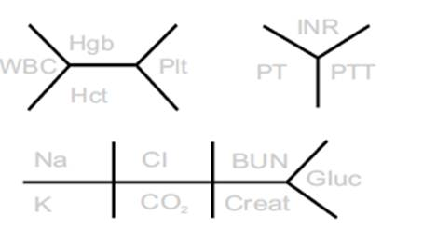
Initials: |  |  | Rm: |  | Initials: |  |  | Rm: |  | Initials: |  |  | Rm:
Neuro |  |  |  |  | Neuro |  |  |  |  | Neuro
HEENT |  |  |  |  | HEENT |  |  |  |  | HEENT
Cardio |  |  |  |  | Cardio |  |  |  |  | Cardio
Pulm |  |  |  |  | Pulm |  |  |  |  | Pulm
GI |  |  |  |  | GI |  |  |  |  | GI
GU |  |  |  |  | GU |  |  |  |  | GU
Integ |  |  |  |  | Integ |  |  |  |  | Integ
M/S |  |  |  |  | M/S |  |  |  |  | M/S
Incisions / Drains / Dressings |  |  |  |  | Incisions / Drains / Dressings |  |  |  |  | Incisions / Drains / Dressings
Meds 7 8 9 10 11 12 13 14 15 16 17 18 19 |  |  |  |  | Meds 7 8 9 10 11 12 13 14 15 16 17 18 19 |  |  |  |  | Meds 7 8 9 10 11 12 13 14 15 16 17 18 19

